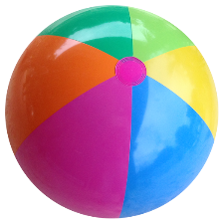

Fun in the Sun Word Scramble
Have Fun While You Unscramble The Words Below
1. | FSHI
2. | RGITE
3. | ZOO
4. | UFN
5. | WGNIS
6. | LAPY
7. |  | IIDKS
8. |  | GSARS
9. |  | THCAC
10. |  | ALMANIS
11. |  | NGSWI
12. |  | SNU

